Partner search/offer
- Relevant topic in work programme
HORIZON-CL2-2026-01-DEMOCRACY-04: Sustainable paths to media viability

HORIZON-CL2-2026-01-DEMOCRACY-05: Research and Innovation Network for a Union of Equality

HORIZON-CL2-2026-01-DEMOCRACY-08: Electoral integrity in the digital context

HORIZON-CL2-2026-01-DEMOCRACY-09: Lifelong learning of citizenship education and citizen participation

HORIZON-CL2-2026-01-DEMOCRACY-10: Digital and media literacy as drivers for democratic and civic resilience

HORIZON-CL2-2027-01-DEMOCRACY-01: Advisory support and network for countering and preventing radicalisation, extremism, hate speech and polarisation

HORIZON-CL2-2027-01-DEMOCRACY-04: Addressing the impact of artificial intelligence, cyberviolence, and deepfakes on equality, democracy and inclusive societies

HORIZON-CL2-2027-01-DEMOCRACY-06: Identifying user-focused solutions to support news media freedom

HORIZON-CL2-2027-01-DEMOCRACY-07: The role of private companies in democracy

HORIZON-CL2-2027-02-DEMOCRACY-09-two-stage: Open topic on reinvigorating and shielding European democracy

- Description of the expertise proposed
- Expertise in media governance; in-depth knowledge of the different legal forms that media outlets can take, and of their advantages and disadvantages. The association has already assisted media outlets on several occasions in choosing their legal form, setting up their governance, and drafting their statutes.
- Economic experience in the field of media economics, enabling it to assist media outlets in defining their business models.
- Experience in the field of advocacy; the association has put forward several strong proposals and has already contributed to the drafting of bills, etc.
- Experience in the field of communication and public relations. The association can thus quickly mobilize public support (through petitions, collective op-eds in newspapers, etc.) to defend media outlets whose independence is under attack.
- Expertise in fundraising, particularly crowdfunding, to support the launch of new media outlets (or media outlets facing economic difficulties that require them to appeal to the generosity of the public).
The association also has in-depth knowledge of the main political actors currently working on media regulation issues.

- Keywords describing the expertise proposed
Civic and citizenship education ; Democratic participation; Experiential and action-oriented learning ; Gamification; Citizen and stakeholder engagement; Inclusion of disadvantaged groups
and gender inclusion ; Policy recommendations ; Link with multiplier public authorities and
organisations ; Participation in other SSH projects

Organisation information

Organisation and country: Un Bout Des Médias (France)
Type of organisation:
□ Enterprise □ SME □ Academic □Research institute □ Public Body ❎ Other: Association
Former participation in FP European projects?
□ Yes ❎ No
Web address: https://www.unboutdesmedias.org/

Description of the organisation:
Un Bout des Médias is a civil society association, without political affiliation, which aims to promote the political and economic independence of the media. Three main types of actions are carried out:
- Un Bout des Médias supports the media who request it by providing its expertise. The association is committed to building virtuous modes of governance in the media and supports the development of a free and pluralistic press and ethical information.

- The association formulates several proposals for an appropriate, respectful and effective legislative framework, and engages in dialogue with the legislator to evolve practices and the law. It also organizes events such as round tables and workshops to discuss the independence of the media, particularly on the occasion of elections.

- Un Bout des Médias carries out pedagogical and communication actions towards the general public. Among these actions, volunteers and administrators intervene with young people to raise awareness about the issues of media independence.

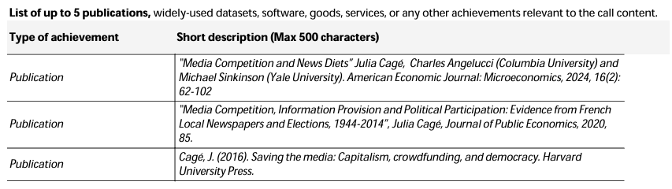
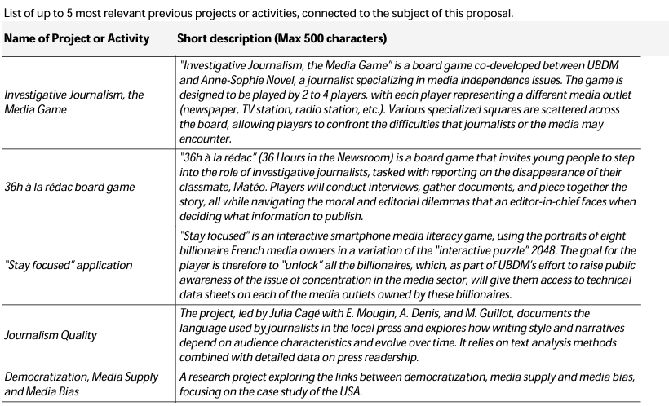

Fact-Checking and Misinformation: Evidence from the Market Leader by Julia Cage, Nathan Gallo, Moritz Hengel, Emeric Henry, Yuchen Huang :: SSRN

Contact details

Contact person name | Julia Cagé (Julia Cagé's Homepage) President and Founder, Un Bout des Médias (non-profit association promoting independent journalism and crowdfunding in the media sector)
E-mail | julia.cage@sciencespo.fr
Country | France

