TEMPLATE FOR AN INTERNAL REGULATION
FOR PROJECT-BASED SUPPLEMENTARY PAYMENTS
February 2023

The primary goal is to establish a set of guidelines that are both compatible with national and Horizon Europe projects. These guidelines will streamline and clarify the process of calculating eligible personnel costs in Horizon Europe projects-based remuneration. This will enable Czech beneficiaries to transition from the fallback option, which relies on the national project daily rate reflecting the average remuneration of an individual over the past year, to a more predictable and objective system governed by their written internal remuneration rules. Introduction of such internal regulation is a voluntary decision of the institution resulting in a possibly more efficient system, it is not an obligation in Horizon Europe.
It was produced by the Czech Financial and Legal National Contact Points for Horizon Europe from Technology Centre Praha and shared with the European Commission (DG RTD) for feedback. While the response from the Commission does not constitute formal or informal approval or endorsement, it is encouraging that there were no significant objections raised and we have made adjustments based on Commission’s recommendations.
It is important to note that while this document is created with our comprehensive expertise, it is intended purely for informational purposes. It should serve as a general resource for institutions to develop their own tailored methodologies.

Written internal regulation for project-based supplementary payments
[FORMAT]
[INSTITUTION OR ITS PART]
Effective for [all/new] relevant projects from [DATE]
For the time worked in projects [TYPE OF PROJECTS] financed from external sources (national and foreign) [FUNDING SCHEMES], a [STAFF] will be paid supplementary payment in the form of [FORM OF THE AMOUNT], in proportion to their working time in the project. The specific amounts are defined in Table 1, reflecting [CRITERIA], and will be paid to the [STAFF] [FREQUENCY].
[TABLE 1]

Explanations:
[FORMAT]
The internal regulation must have a written, formally binding format (e.g., the form of a directive or methodological guidance or other, depending on the usual internal practices of the institution and in line with the applicable legislation).
[INSTITUTION OR ITS PART]
The internal regulation must be applied consistently by the whole institution or identified part of the institution (e.g., the faculty or department) in line with the applicable legislation.
[DATE]
The internal regulation applies either to all projects the institution began to implement after the effective days or to all projects that the institution already implements after the effective day, depending on the institution's decision and in line with the applicable legislation.
[TYPE OF PROJECT]
The internal regulation must identify the relevant scope of the project (e.g., research and innovation projects, projects supporting research and innovation activities, educational projects, and others). Furthermore, more detailed identification of the project can be used, too (e.g., research and innovation projects with an international dimension). The regulation can be applied only to one type or more, depending on the institution's decision.
[FUNDING SCHEME]
The internal regulation must identify the relevant pool of funding schemes, i.e., external funding sources from national and foreign sources. The internal regulation needs to be used with respect to the rules and specifics of individual funding schemes and projects. The list must include specific existing funding schemes and a general description of other possible funding schemes meeting the same requested criteria.
Horizon Europe: specifics
To be used in the Horizon Europe programme, the relevant funding scheme can be an EU scheme (or inter-national one) AND at least one national scheme that is closest to Horizon Europe by its nature. For this purpose, the national scheme is understood in a broad sense, meaning all types of projects funded under any national (public or private) funding scheme, including projects co-financed by EU funds managed by the Member States.
The broader the pool of relevant national schemes, the better. The broader the pool of relevant foreign schemes, the better. At the same time, however, specific types of projects and funding schemes in which the funding body specifies the level of the remuneration/supplementary payment are not included (e.g., MSCA actions, which apply unit cost determined by the European Commission, or some projects financed by national funding agencies, in which the level of remuneration/ supplementary payment is already established). In addition, funding schemes that do not allow the payment of supplementary payments are also not included (unless the institution chooses to pay such supplementary payments from its own/other sources).
The choice of relevant funding schemes does not depend on whether or not the institution has already implemented a project under the scheme. What is important is that it is an existing scheme relevant in content to the institution.
Horizon 2020: specifics
In case the H2020 programme is included in the pool, it is essential to bear in mind that project-based supplementary payments can be eligible in H2020 only if those amounts were actually paid at least once before submitting the H2020 proposal for work in a national project.
[STAFF]
The internal regulation applies to all employees or only identified staff categories, depending on the institution's decision.
[FORM OF THE AMOUNT]
The supplementary payment can have a different form depending on the institution's decision (e.g., % of clearly identified bases, a certain amount per month, a certain amount per hour/day worked in the project, or other).
[CRITERIA]
The internal regulation can identify different amounts for different employees fulfilling different criteria (e.g., their role in the project such as principal investigator and researcher, their position and seniority, the size of the project being implemented, or other objective criteria), in accordance with the decision of the institution. It is up to the institution's decision whether to use more complex systems differentiating the level of supplementary payments depending on a greater number of criteria or just a simple one. The defined system must be applied consistently.
[TABLE 1]
Specific amounts are specified in Table 1.
Suppose the internal regulation provides for a bonus range or a maximum ceiling rather than a specific amount. In that case, the remuneration to which the person would be entitled to in Horizon Europe projects (national project daily rate) is the average of the remuneration received for work in other than EU projects in the last complete year before the end of the reporting period.
[FREQUENCY]
Frequency of the payment of the supplementary payment depends on the institution's decision. The most common is likely to be monthly in the employee's monthly salary. However, a lower frequency (e.g., yearly in the form of a yearly bonus) is also possible.

EXAMPLE 1

Written internal regulation for project-based supplementary payments
methodological guidance of the Dean
Faculty of Philosophy, University Prague
Effective for new projects from 1.1.2023

For the time worked on excellent research and innovation projects financed from the following external sources (national and foreign):

- EU Programme Horizon Europe
- Czech Science Foundation JUNIOR STAR
- Czech Science Foundation EXPRO
- Technology Agency of the Czech Republic - NATIONAL CENTRES OF COMPETENCE
- Ministry of Education, Youth and Sports - ERC CZ
- Ministry of Education, Youth and Sports - Johannes Amos Comenius Programme (P JAC) - SO 1.1
- Other funding schemes which, according to the call text, support excellence in research
employees are entitled to supplementary payments in the form of an extra % of mandatory parts of their salary defined in their salary statement, in proportion to their working time in the project. The specific percentages, reflecting the project′s role, are defined in Table 1. Supplementary payments will be paid to the employees on monthly bases in their salary.
Table 1
Role in the project | The amount of the supplementary payment per month (for full-time equivalent)
Principal investigator | 30 %
Researcher and/or other staff member | 10 %

EXAMPLE CALCULATION: Horizon Europe (HE) project (using the reporting period methodology)
Reporting period: 01/01/2023 – 30/6/2024
1,0 FTE Employee A (principal investigator in the HE project, working at 50 % of his/her workload, representing 161,5 day-equivalents worked on the HE project in the respective reporting period)
01/01/2023 – 31/12/2023…. monthly salary 4 600,- consisting of:
- 3 000,- euro tariff (identified in the employee's salary statement)
- 1 000,- euro merit pay (identified in the employee's salary statement)
- 600,- euro project-based supplementary payments (based on this internal regulation – 30 % top up to salary identified in the employee's salary statement, reflecting 50 % workload)
01/01/2024 – 30/6/2024…. monthly salary 5 750,- consisting of:
- 3 000,- euro tariff (identified in the employee's salary statement)
- 2 000,- euro merit pay (identified in the employee's salary statement)
- 750,- euro project-based supplementary payments (based on this internal regulation – 30 % top up to salary identified in the employee's salary statement, reflecting 50 % workload)
Calculation of eligible personnel costs in the HE project:
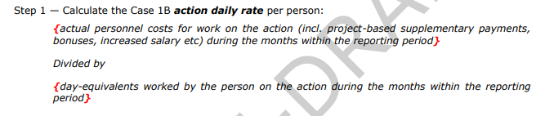
Actual personnel costs for work on the action = (4 000 * 0,5 + 600) * 12 + (5 000 * 0,5 + 750) * 6 = 31 200 + 19 500 = 50 700
Day-equivalents worked by the person on the action (see declaration/timesheets and round it to the nearest half-day) = 161,5
Action daily rate = 50 700 / 161,5 = 313,931
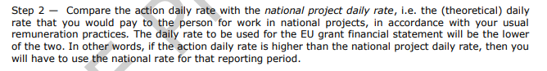
Option 2: The national project daily rate must be calculated based on the formula identified in the Annotated Model Grant Agreement
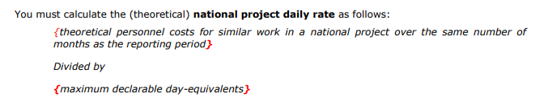
Theoretical personnel costs for similar work in a national project = (4 000 + 1 200)] * 12 + (5 000 + 1 500) * 6 = 62 400 + 39 000 = 101 400
Maximum declarable day-equivalents for the reporting period = (215/12) * 18 = 322,5 (already rounded to the nearest half-day)
Theoretical national daily rate = 101 400 / 322,5 = 314,419
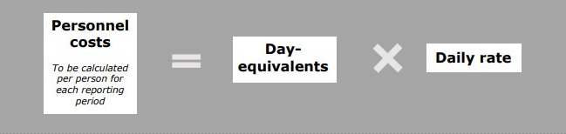
Eligible personnel costs = 161,5 *313,931= 50 700 EUR

EXAMPLE 2

Written internal regulation for project-based supplementary payments
methodological guidance of the Dean
Faculty of Physics, University Prague
Effective for new relevant projects from 1.1.2024
For the time worked on excellent research and innovation projects financed from the following external sources (national and foreign):

- EU Programme Horizon Europe
- Czech Science Foundation JUNIOR STAR
- Czech Science Foundation EXPRO
- Technology Agency of the Czech Republic - NATIONAL CENTRES OF COMPETENCE
- Ministry of Education, Youth and Sports - ERC CZ
- Ministry of Education, Youth and Sports - Johannes Amos Comenius Programme (P JAC) - SO 1.1
- Other funding schemes which, according to the call text, support excellence in research
employees will be paid supplementary payments in the form of a bonus paid for each hour spent on the project implementation. The specific amounts reflecting the project′s role, are defined in Table 1. Supplementary (bonus) payments will be paid to the employees on monthly / quarterly / bi-annually bases in their salary.
Table 1
Role in the project | The amount of the supplementary payment per hour spent on project implementation
Principal investigator | 15 EUR
Researcher | 10 EUR

EXAMPLE CALCULATION: Horizon Europe (HE) project (using the reporting period methodology)
Reporting period: 01/01/2023 – 30/6/2024
1,0 FTE Employee A (principal investigator in the HE project worked 1 998 hours for the HE project. The number of overall productive hours of the employee in the reporting period is 2 700 hours (national holidays, holidays and sick leave are deducted). The eligible fixed monthly salary (non-project based) is 2 500 EUR.
Calculation of eligible personnel costs in the HE project:
Actual personnel costs for work on the action = (2 500 * 18) * (1 998 / 2700) + (15 * 1 998) = 63 270
Day-equivalents worked by the person on the action (see declaration/timesheets and round it to the nearest half-day) = 1 998 / 8 = 249,75 rounded to 250
Action daily rate = 63 270 / 250 = 253,08
Option 2: The national project daily rate must be calculated based on the formula identified in the Annotated Model Grant Agreement
Theoretical personnel costs for similar work in a national project = (2 500 * 18) + (15 * 2700) = 85 500
Maximum declarable day-equivalents for the reporting period = (215/12) * 18 = 322,5 (already rounded to the nearest half-day)
Theoretical national daily rate = 85 500 / 322,5 = 265,12 EUR

Eligible personnel costs = 250 * 253,08 = 63 270 EUR

